Hospital Week – Facebook Messaging
May 7
#HospitalWeek starts today! Join AHA’s #MyHospital campaign by sharing photos or videos describing what our hospital means to the community. Use #MyHospital and tag @AHAhospitals to share your photos or videos and AHA will promote them on various social media platforms throughout the week. They will also be displayed on AdvancingHealthinAmerica.org.
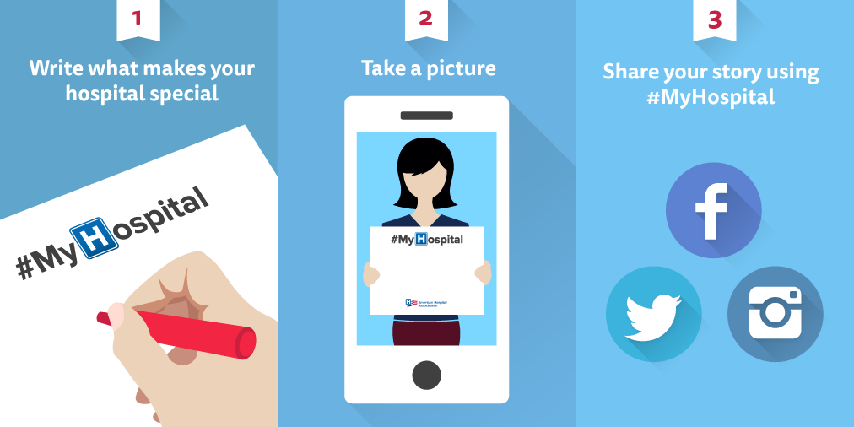

May 8
In honor of #HospitalWeek, we at [Hospital Name] would like to express our deep appreciation of our employees who go above and beyond to take the absolute best care of their patients and communities. Thank you.

May 9
Today, our hospital would like to send a tremendous “THANK YOU” to the more than 5.7 million hospital employees across the country. #HospitalWeek

May 10
Did you know that National Hospital Week was first celebrated in 1921? That also happens to be the same year that IHA was formed as a section of the American Hospital Association. Together, IHA and AHA work with hospitals and health systems like ours to improve the health of Hoosiers and Americans. #HospitalWeek

May 11
#HospitalWeek is a great time to reflect on all of the work each and every hospital employee does to ensure the safety and well-being of Hoosier patients. Thank you for contributing to a #HealthierIndiana.

May 12
Hospitals in the state of Indiana employ more than 150,000 Hoosiers. Without them, hospitals would not be able to provide safe and effective care. Thank you for all you do! #HospitalWeek

May 13
Thanks once more to each and every hospital employee in Indiana for helping ensure the safety and well-being of over 3 million Hoosier patients every year. #HospitalWeek
Hospital Week – Twitter Messaging
May 7
#HospitalWeek begins today! What do you think our hospital brings to your community? Tell us using #MyHospital and [@hospitalhandle].
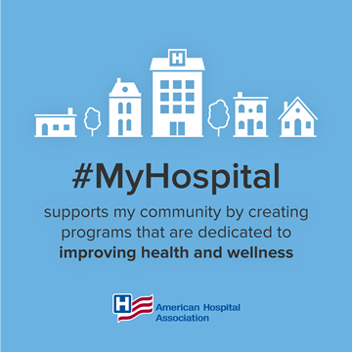

May 8
This week, you’ll notice our profile picture is the hospital “H” in recognition of #HospitalWeek. Feel free to join us!
[Download here -http://www.aha.org/images/twitter-h.png]

May 9
Indiana hospitals are always #ReadytoCare. #HospitalWeek https://youtu.be/D3UFTh7Voa4

May 10
Did you know Indiana hospitals employ over 150,000 Hoosiers? #HospitalWeek

May 11
Each year, Indiana hospitals serve over 3 million Hoosiers! #HospitalWeek

May 12
#Hospitals are an economic mainstay, providing more than 5.7 million jobs across the U.S. #HospitalWeek

May 13
Thanks once more to each and every hospital employee who ensures the safety and well-being of Hoosier patients every day. #HospitalWeek
More graphics:

